**SQL BASICS 2**

1.CREATE TABLE EMPLOYEE (

SERIALNUMBER int NOT NULL,

NAME varchar(255) NOT NULL,

ROLE varchar(255) NOT NULL,

PHONENUMBER varchar(255) NOT NULL,

);

CREATE TABLE PERSON (

SERIALNUMBER int NOT NULL,

NAME varchar(255) NOT NULL,

ACHIEVEMENTNAME varchar(255) NOT NULL,

ACHIEVEMENTYEAR date NOT NULL,

CITY varchar(255) NOT NULL,

PHONENUMBER varchar(255) NOT NULL,

);

INSERT INTO EMPLOYEE

VALUES

(1,'SEMA','ENGINEER',9758459875),

(2,'MINT','FLORIST',7792972979),

(3,'QLOI','SCIENTIST',7792972979);

INSERT INTO PERSON

VALUES

(1,'SEMA','AREE','2011-11-12','GINGAR',9758459875),

(2,'QLOI','YTDO','2018-04-18','BUTINOI',7792972979);

JOINS:

1. INNERJOIN:

SELECT *

FROM PERSON

INNER JOIN EMPLOYEE ON PERSON.NAME =EMPLOYEE.NAME;

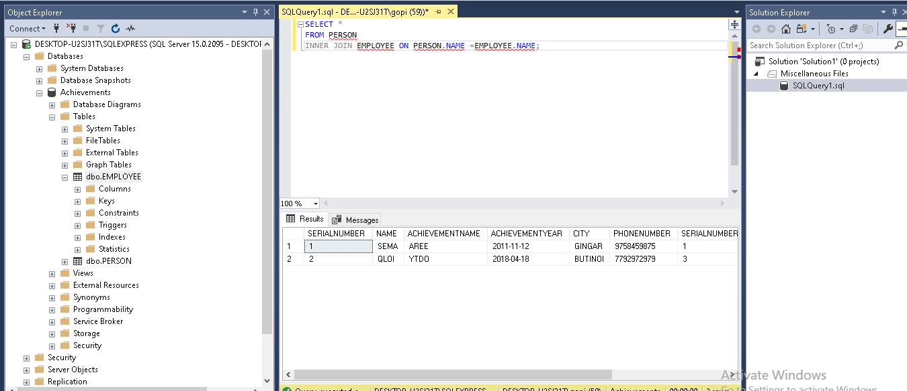

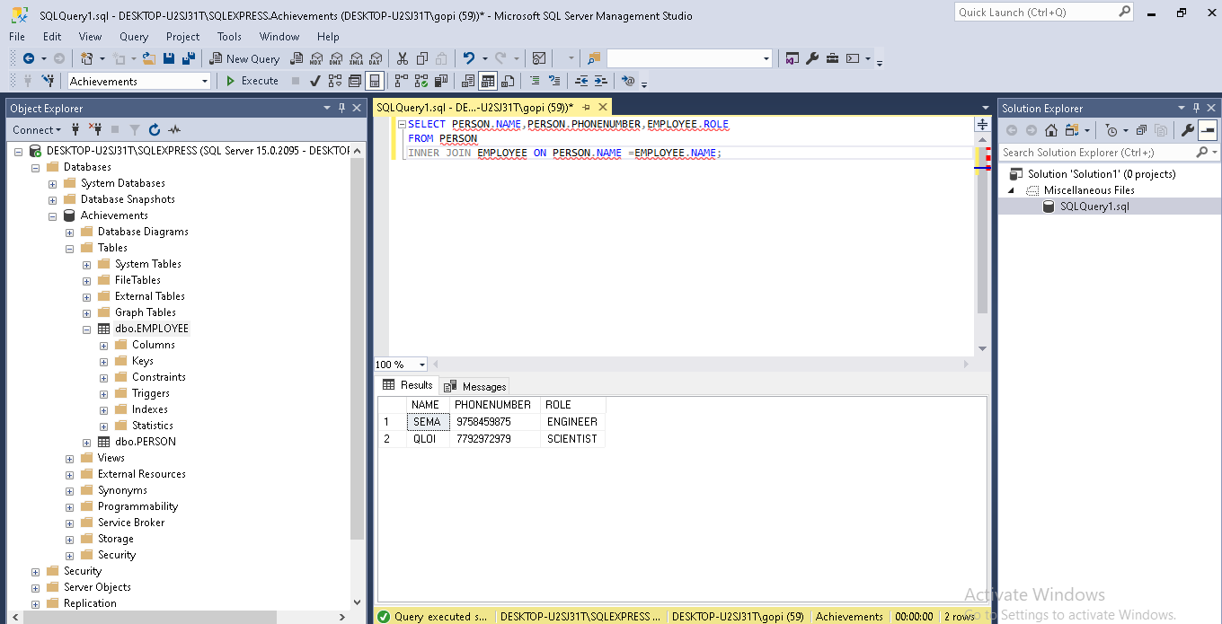

2) LEFT JOIN: L

SELECT PERSON.NAME,PERSON.PHONENUMBER,EMPLOYEE.ROLE

FROM EMPLOYEE

LEFT JOIN PERSON ON PERSON.SERIALNUMBER = EMPLOYEE.SERIALNUMBER;

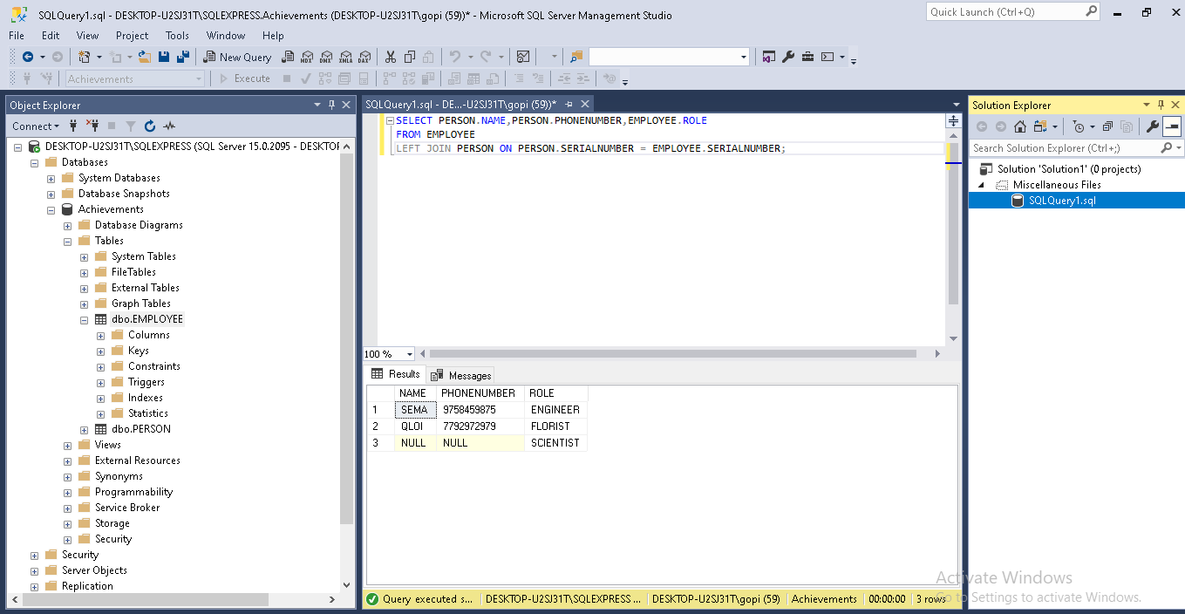

1. RIGHT JOIN: LSELECT *

FROM EMPLOYEE

RIGHT JOIN PERSON ON PERSON.NAME= EMPLOYEE.NAME;

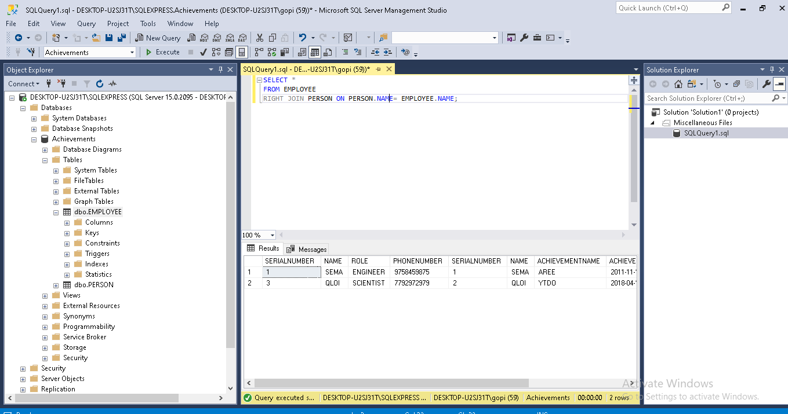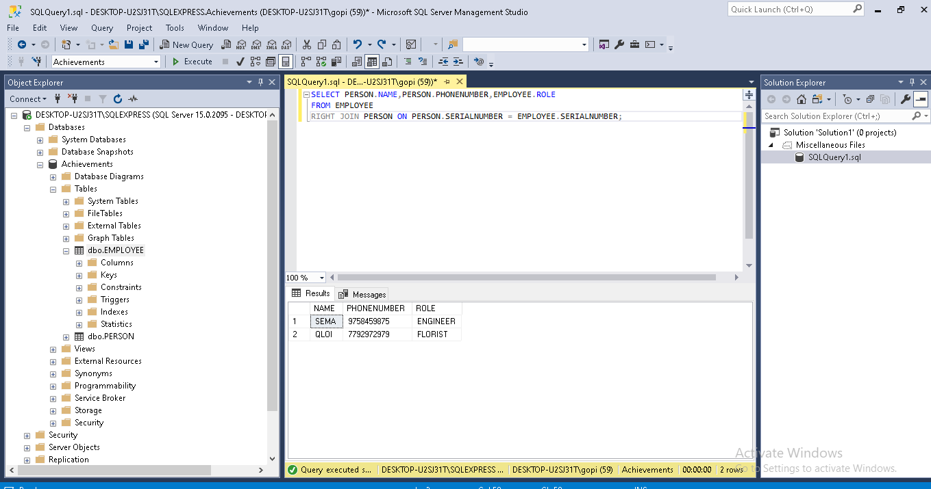

4) FULL OUTER JOIN:

SELECT EMPLOYEE.NAME,PERSON.NAME

FROM EMPLOYEE

FULL OUTER JOIN PERSON

ON PERSON.NAME = EMPLOYEE.NAME;

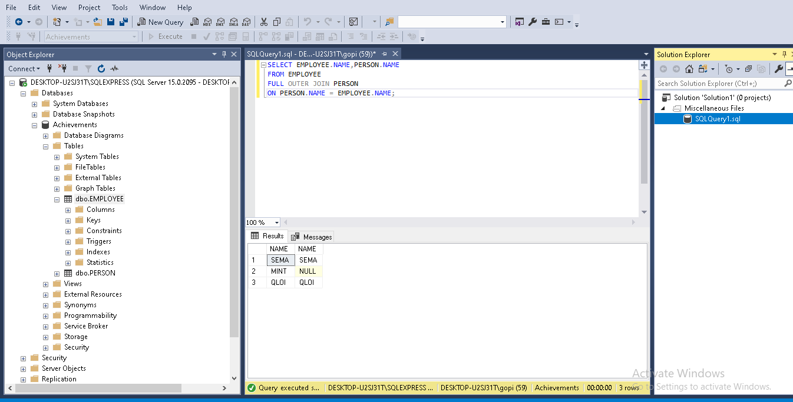

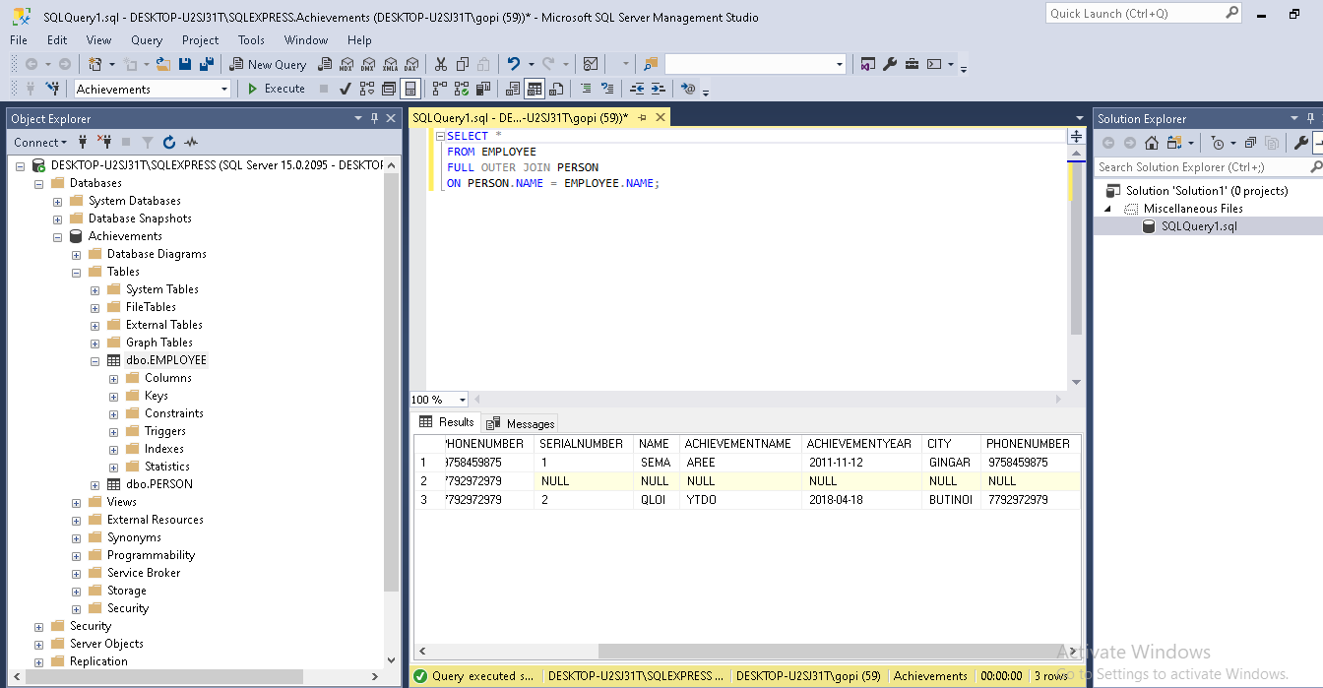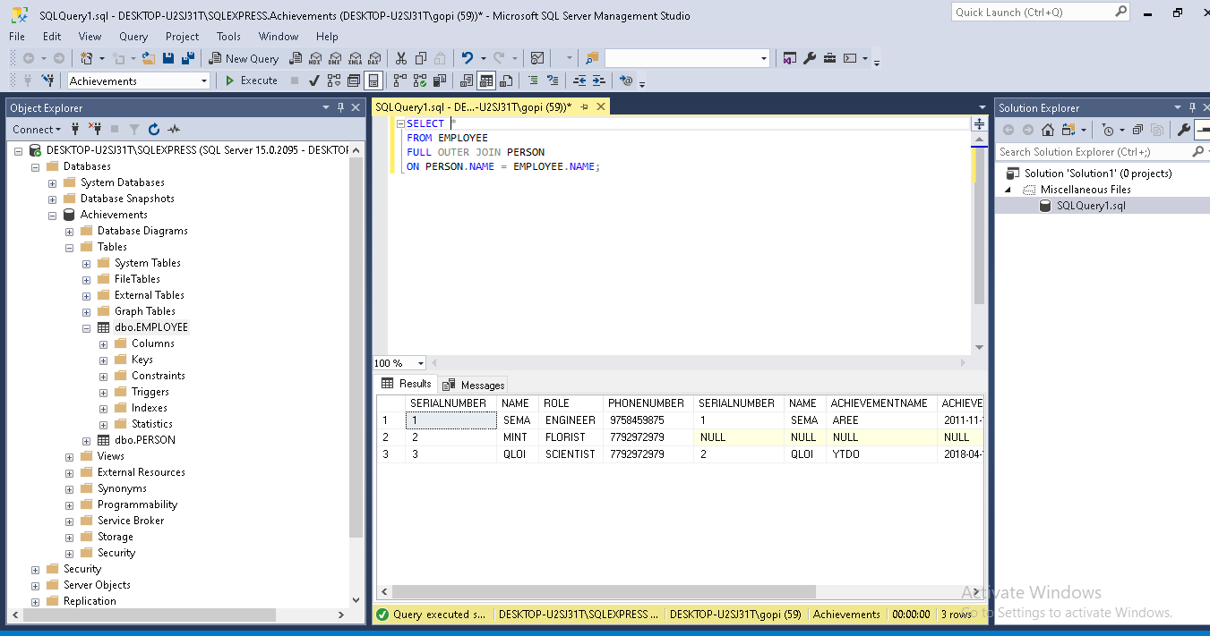

## SQL HAVING

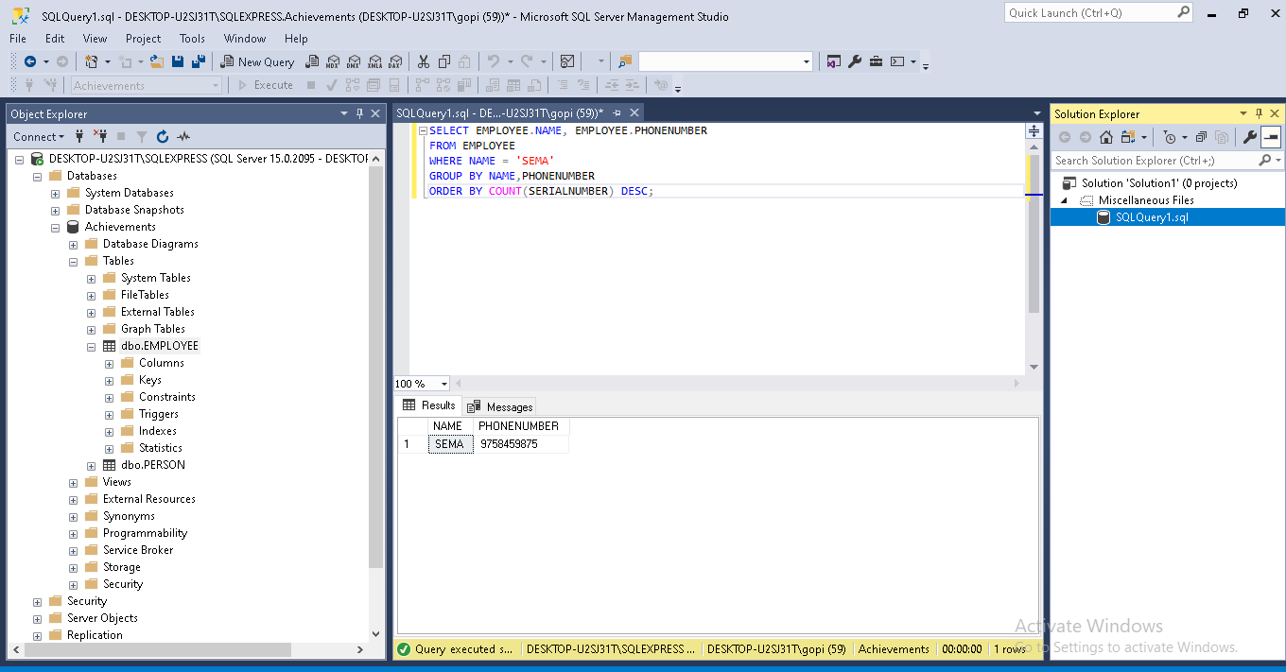

## SQL CREATE INDEX Statement:

The CREATE INDEX statement is used to create indexes in tables.

Indexes are used to retrieve data from the database more quickly than otherwise. The users cannot see the indexes, they are just used to speed up searches/queries.

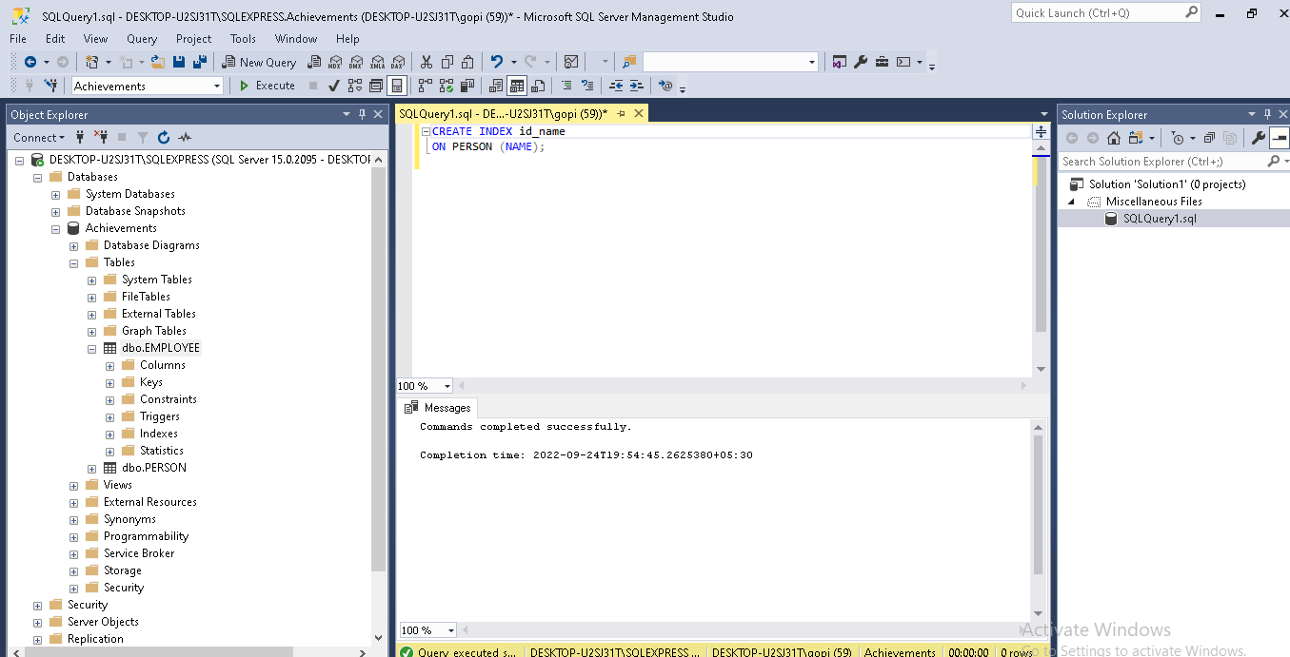

# SQL Views:

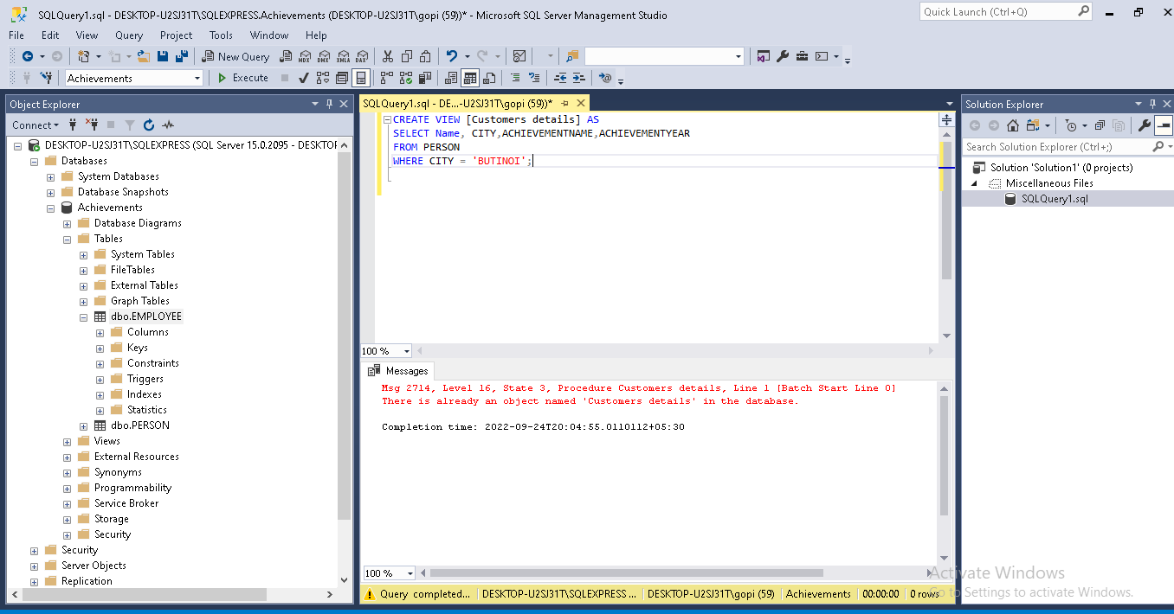

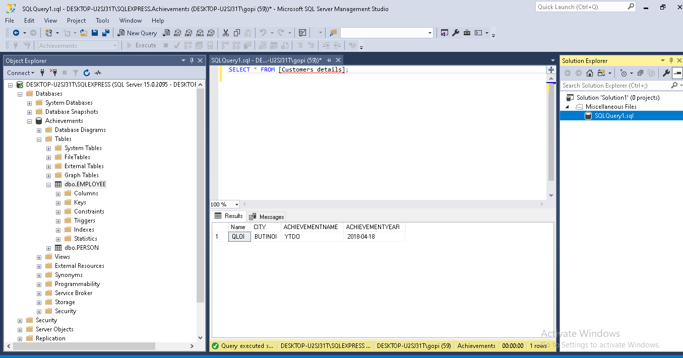

SQL Stored Procedures for SQL Server:

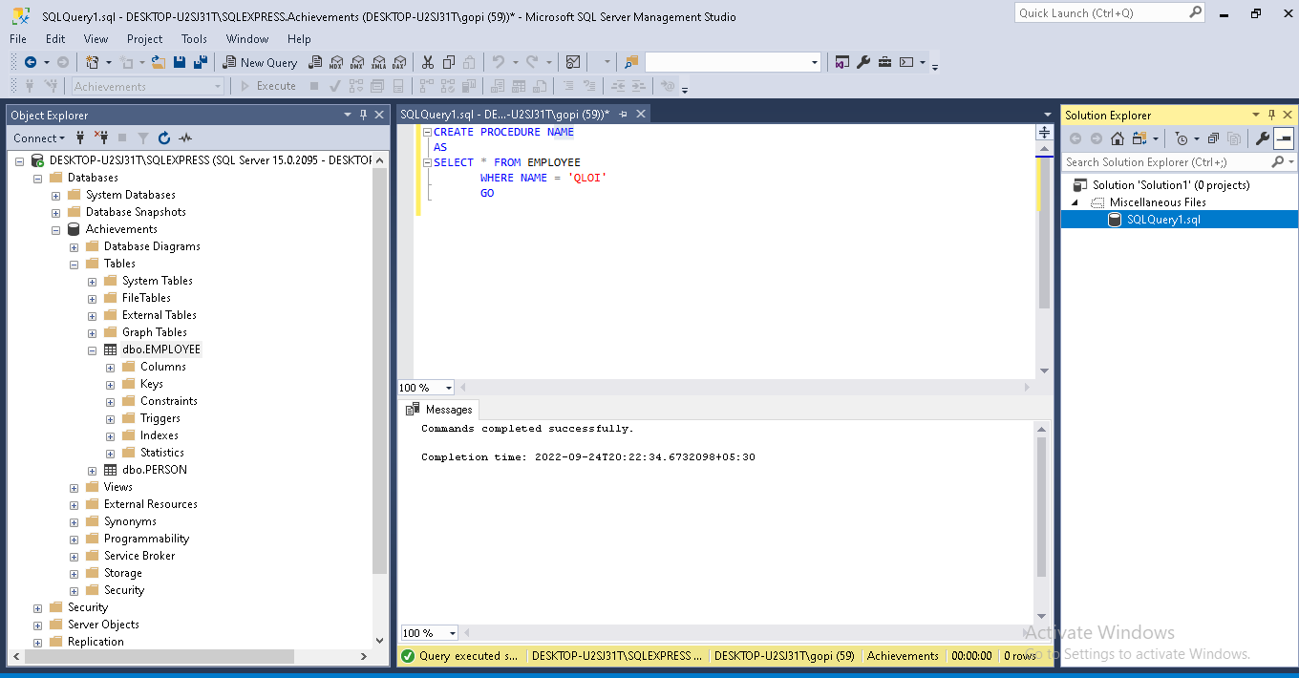

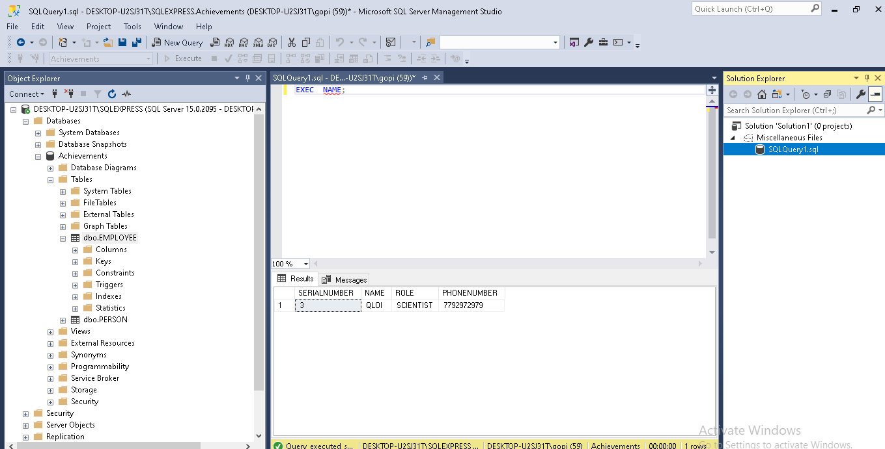

**1. Clustered Index :**   
Clustered index is created only when both the following conditions satisfy –

1. The data or file, that you are moving into secondary memory should be in sequential or sorted order.
2. There should be a key value, meaning it can not have repeated values.

Whenever you apply clustered indexing in a table, it will perform sorting in that table only. You can create only one clustered index in a table like primary key. Clustered index is as same as dictionary where the data is arranged by alphabetical order.

In clustered index, index contains pointer to block but not direct data. 

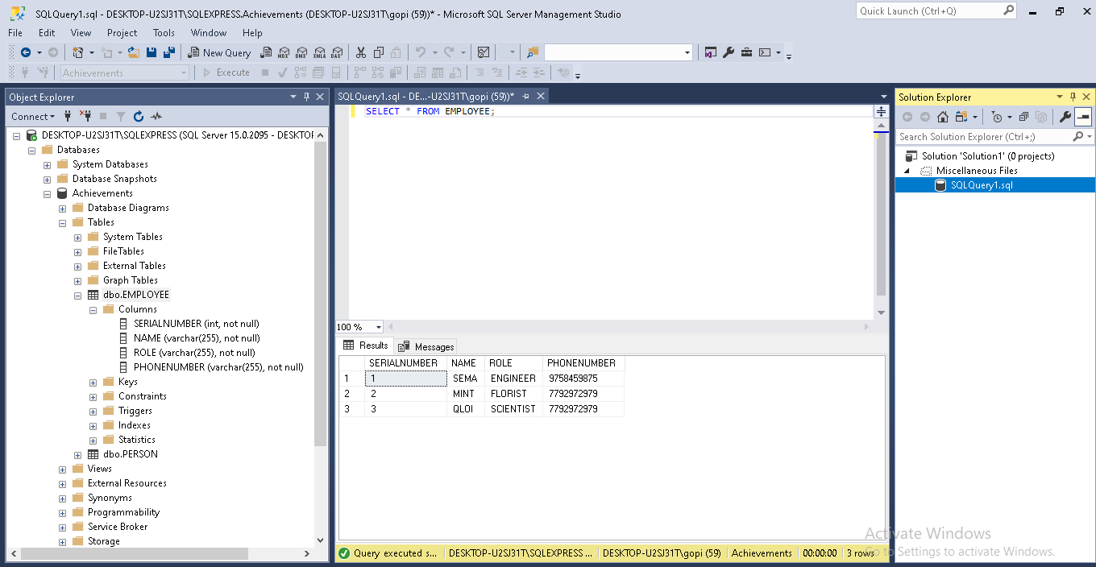

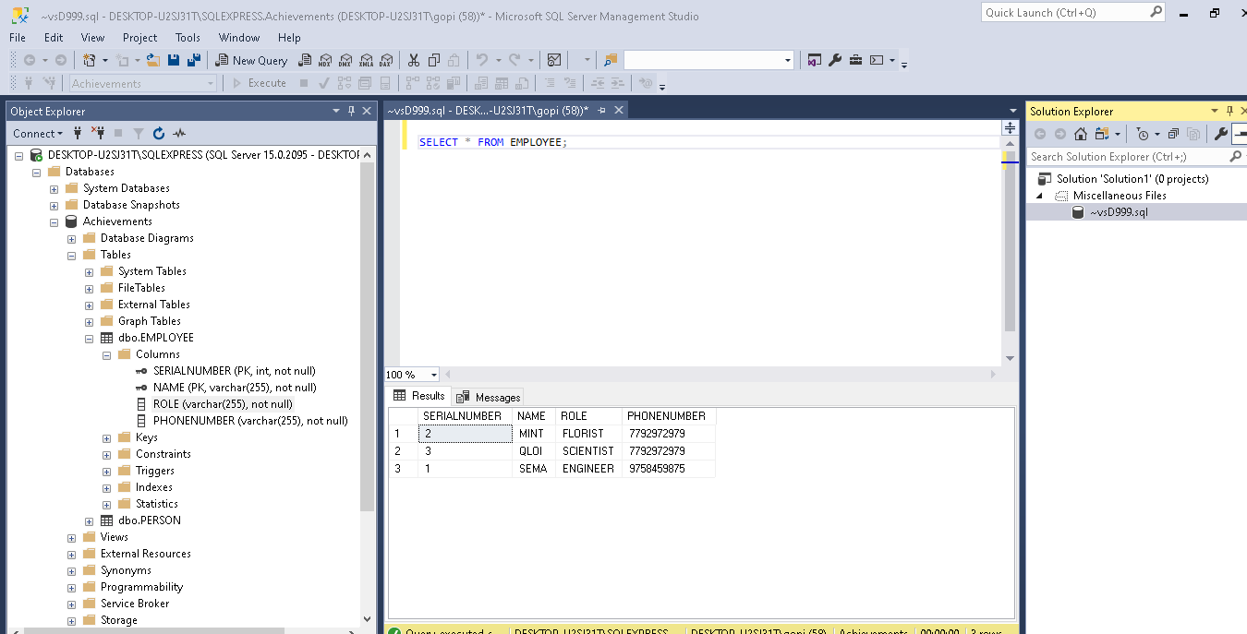

**2. Non-clustered Index :**   
Non-Clustered Index is similar to the index of a book. The index of a book consists of a chapter name and page number, if you want to read any topic or chapter then you can directly go to that page by using index of that book. No need to go through each and every page of a book.

The data is stored in one place, and index is stored in another place. Since, the data and non-clustered index is stored separately, then you can have multiple non-clustered index in a table.

In non-clustered index, index contains the pointer to data.

